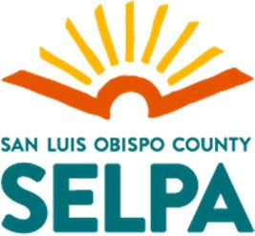
Student Name Date of Birth / / IEP Date / /

Strengths/Preferences/Interests
Concerns of parent relevant to educational progress
Smarter Balanced Assessment Consortium (SBAC)
English/Language Arts Overall Not Applicable
Standard Exceeded Standard Met Standard Nearly Met Standard Not Met

Reading Above Standard Near Standard Below Standard
Writing Above Standard Near Standard Below Standard
Speaking and Listening Above Standard Near Standard Below Standard
Research/Inquiry Above Standard Near Standard Below Standard

Math Overall Not Applicable
Standard Exceeded Standard Met Standard Nearly Met Standard Not Met
Concepts and Procedures Above Standard Near Standard Below Standard
Problem Solving and Data Analysis Above Standard Near Standard Below Standard
Communication Reasoning Above Standard Near Standard Below Standard

California Alternate Assessments (CAA) Not Applicable
English Language Arts Understanding Foundational Understanding Limited Understanding
Math Understanding Foundational Understanding Limited Understanding
Science Understanding Foundational Understanding Limited Understanding

English Language Development Test (English Learners Only)
Not Applicable
California English Language Development Test (CELDT)
English Language Proficiency Assessments for California (ELPAC)
Alternate Assessment to ELPAC
Other

Overall Listening Speaking Reading Writing
Physical Education Testing (grades 5, 7 & 9):

Other Assessment Data (e.g., curriculum assessment, other district assessment, etc.)

Hearing Date / / Pass Fail Other
Vision Date / / Pass Fail Other

Preacademic/Academic/Functional Skills
Communication Development

Gross/Fine Motor Development
Social Emotional/Behavioral
Vocational
Adaptive/Daily Living Skills
Health
For student to receive educational benefit, goals will be written to address the following areas of need:

